Digital Image Processing
ASSIGNMENT -6
Perumalla Dharan
AP21110010201
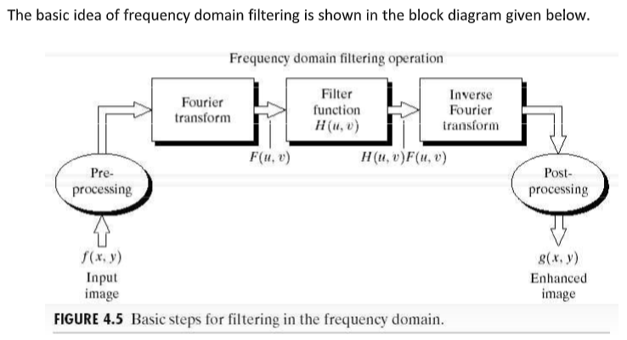
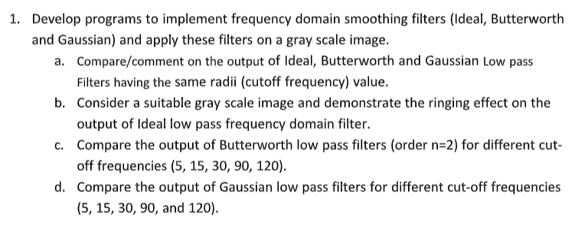

import cv2
import numpy as np
import matplotlib.pyplot as plt
from numpy.fft import fft2, fftshift, ifft2, ifftshift

img = cv2.imread(r"E:\SRM\Digital Image\Lab 6 - 14th October\test_image.png", 0)

f_transform = fft2(img)
f_transform_shifted = fftshift(f_transform)
magnitude_spectrum = np.log(np.abs(f_transform_shifted) + 1)

plt.figure(figsize=(12,6))
plt.subplot(1,2,1), plt.imshow(img, cmap='gray'), plt.title("Original Image")
plt.subplot(1,2,2), plt.imshow(magnitude_spectrum, cmap='gray'), plt.title("Magnitude Spectrum")
plt.show()

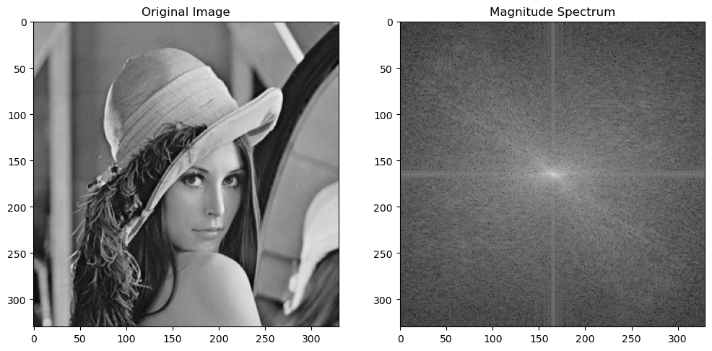

# Ideal Low-Pass Filter
def ideal_low_pass_filter(shape, D0):
M, N = shape
U, V = np.meshgrid(np.arange(M), np.arange(N), indexing='ij')
D = np.sqrt((U - M/2)**2 + (V - N/2)**2)
H = np.where(D <= D0, 1, 0).astype(np.float32)
return H

# Butterworth Low-Pass Filter
def butterworth_low_pass_filter(shape, D0, n):
M, N = shape
U, V = np.meshgrid(np.arange(M), np.arange(N), indexing='ij')
D = np.sqrt((U - M/2)**2 + (V - N/2)**2)
H = 1 / (1 + (D / D0) ** (2 * n)).astype(np.float32)
return H

# Gaussian Low-Pass Filter
def gaussian_low_pass_filter(shape, D0):
M, N = shape
U, V = np.meshgrid(np.arange(M), np.arange(N), indexing='ij')
D = np.sqrt((U - M/2)**2 + (V - N/2)**2)
H = np.exp(-(D ** 2) / (2 * (D0 ** 2))).astype(np.float32)
return H

# Apply a filter and perform inverse Fourier Transform
def apply_filter_and_inverse(f_transform_shifted, H):
Gshift = f_transform_shifted * H
G = ifftshift(Gshift)
g = np.abs(ifft2(G))
return g

# Plotting function to compare original and filtered image
def plot_images(original, filtered, title):
plt.figure(figsize=(12, 6))
plt.subplot(1, 2, 1)
plt.imshow(original, cmap='gray')
plt.title("Original Image")
plt.axis('off')

plt.subplot(1, 2, 2)
plt.imshow(filtered, cmap='gray')
plt.title(title)
plt.axis('off')
plt.show()

# Set cutoff frequency
cutoff = 50

# Ideal Low-Pass Filter
H_ideal = ideal_low_pass_filter(img.shape, cutoff)
ideal_filtered_img = apply_filter_and_inverse(f_transform_shifted, H_ideal)
plot_images(img, ideal_filtered_img, f"Ideal Low Pass Filter (D0={cutoff})")

# Butterworth Low-Pass Filter (Order 2)
n = 2
H_butterworth = butterworth_low_pass_filter(img.shape, cutoff, n)
butterworth_filtered_img = apply_filter_and_inverse(f_transform_shifted, H_butterworth)
plot_images(img, butterworth_filtered_img, f"Butterworth Low Pass Filter (n={n}, D0={cutoff})")

# Gaussian Low-Pass Filter
H_gaussian = gaussian_low_pass_filter(img.shape, cutoff)
gaussian_filtered_img = apply_filter_and_inverse(f_transform_shifted, H_gaussian)
plot_images(img, gaussian_filtered_img, f"Gaussian Low Pass Filter (D0={cutoff})")

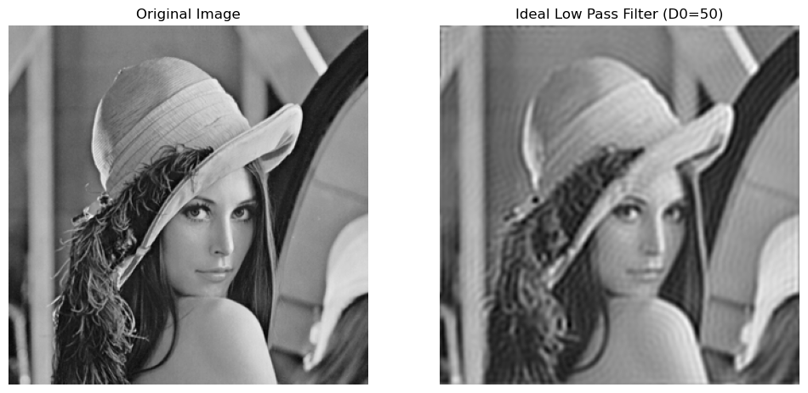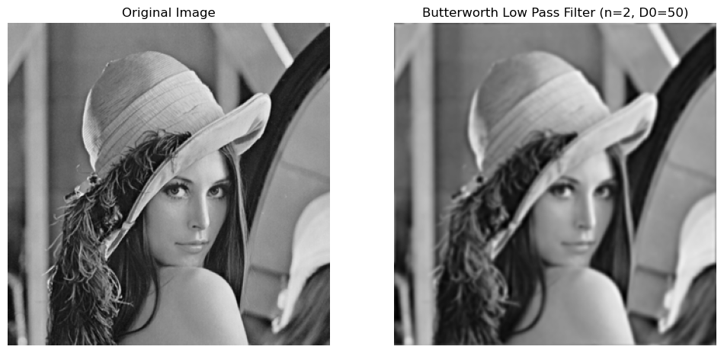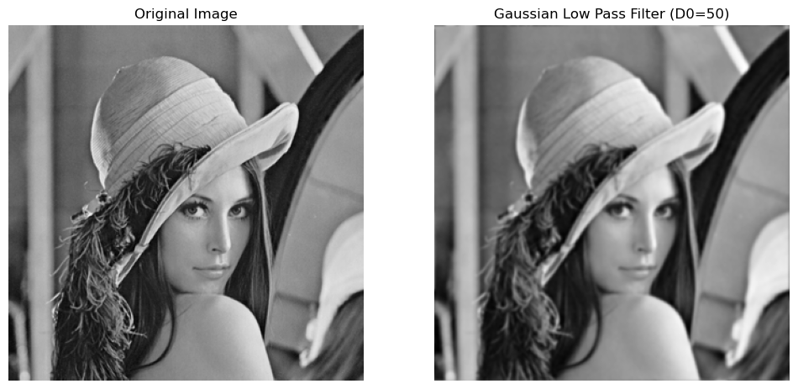
# Apply Ideal Low-Pass Filter with ringing effect demonstration
cutoff = 30 # Sharp cut-off frequency to highlight ringing
H_ideal_ringing = ideal_low_pass_filter(img.shape, cutoff)
ideal_filtered_img_ringing = apply_filter_and_inverse(f_transform_shifted, H_ideal_ringing)
plot_images(img, ideal_filtered_img_ringing, f"Ideal Low Pass Filter - Ringing Effect (D0={cutoff})")

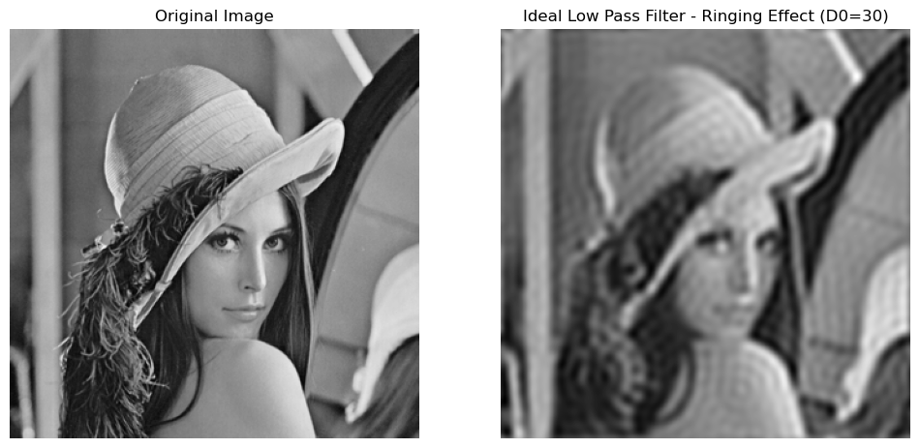
# Compare Butterworth Low-Pass Filters for different cutoff frequencies
cutoffs = [5, 15, 30, 90, 120]
n = 2 # Fixed order of the filter

for c in cutoffs:
H_butterworth = butterworth_low_pass_filter(img.shape, c, n)
butterworth_filtered_img = apply_filter_and_inverse(f_transform_shifted, H_butterworth)
plot_images(img, butterworth_filtered_img, f"Butterworth Low Pass Filter (n={n}, D0={c})")

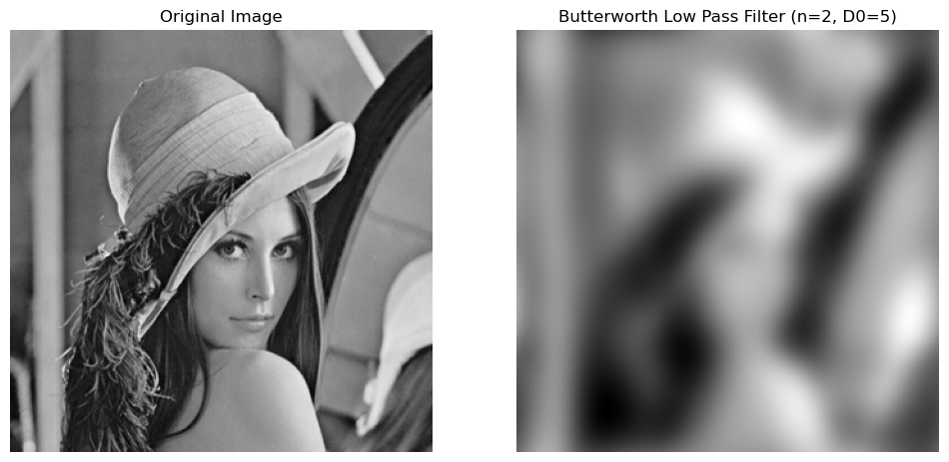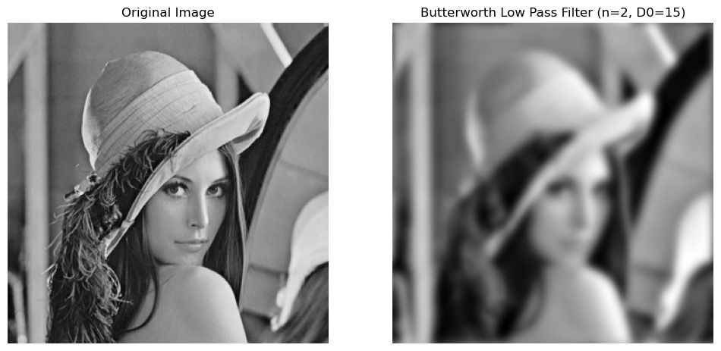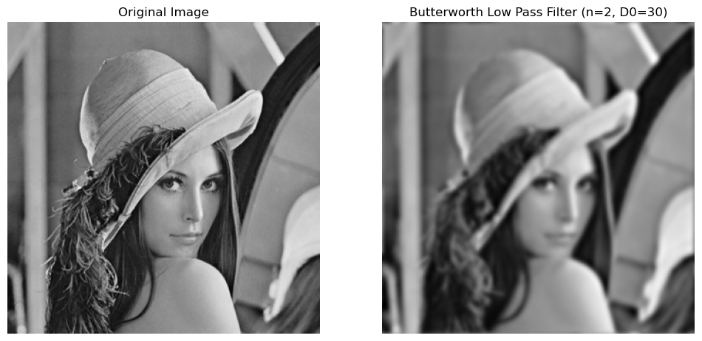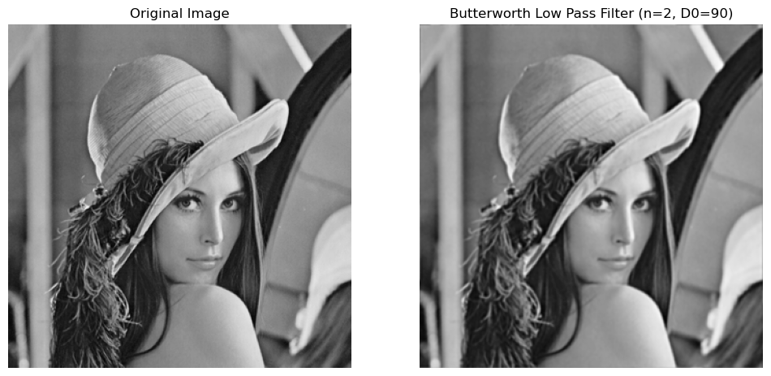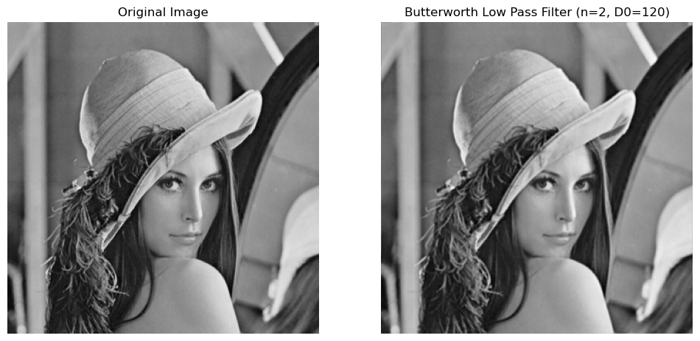
# Compare Gaussian Low-Pass Filters for different cutoff frequencies
cutoffs = [5, 15, 30, 90, 120]

for c in cutoffs:
H_gaussian = gaussian_low_pass_filter(img.shape, c)
gaussian_filtered_img = apply_filter_and_inverse(f_transform_shifted, H_gaussian)
plot_images(img, gaussian_filtered_img, f"Gaussian Low Pass Filter (D0={c})")

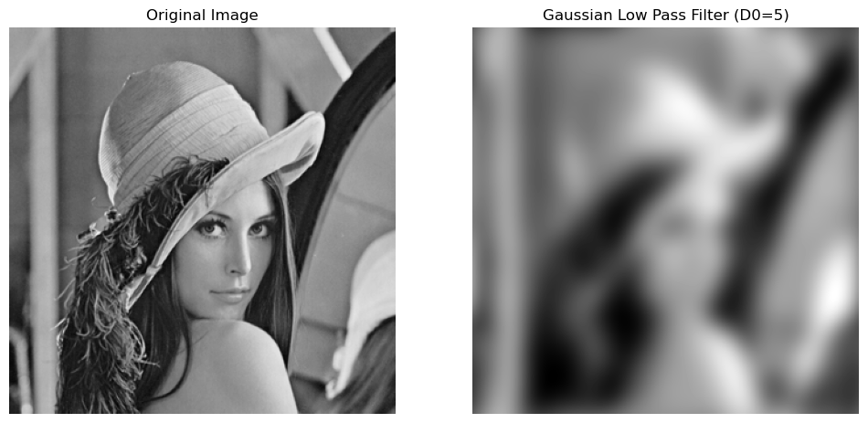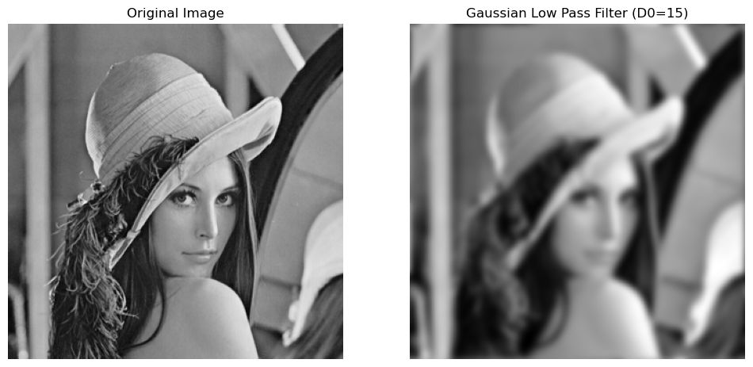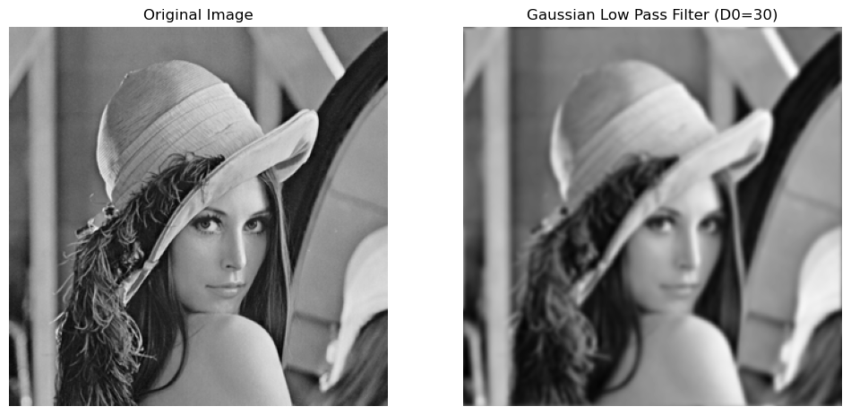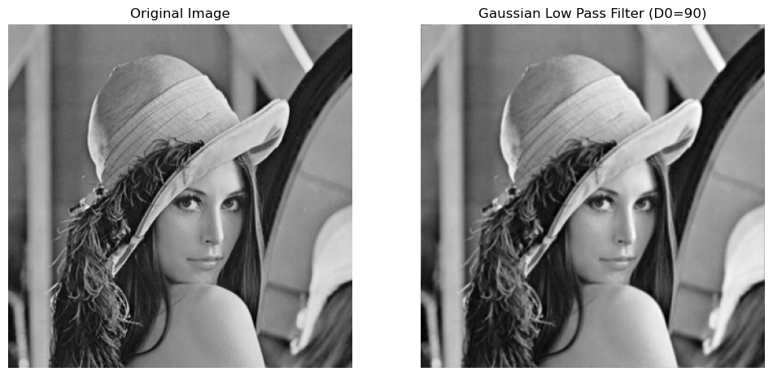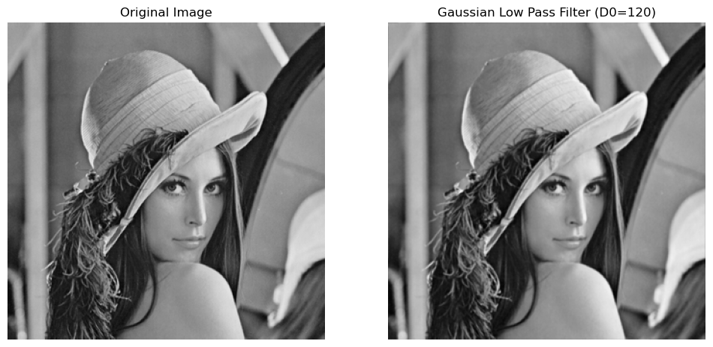

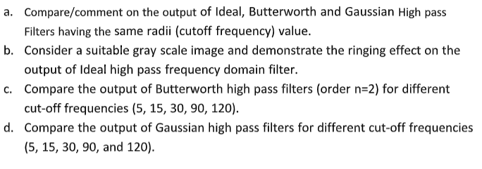
# Required Libraries
import cv2
import numpy as np
import matplotlib.pyplot as plt
from numpy.fft import fft2, fftshift, ifft2, ifftshift

# Load the image (grayscale)
img = cv2.imread(r"E:\SRM\Digital Image\Lab 6 - 14th October\test_image.png", 0)

# Fourier Transform
f_transform = fft2(img)
f_transform_shifted = fftshift(f_transform)
magnitude_spectrum = np.log(np.abs(f_transform_shifted) + 1)

# Display the original image and its Fourier Transform
plt.figure(figsize=(12,6))
plt.subplot(1,2,1), plt.imshow(img, cmap='gray'), plt.title("Original Image")
plt.subplot(1,2,2), plt.imshow(magnitude_spectrum, cmap='gray'), plt.title("Magnitude Spectrum")
plt.show()


# Ideal High-Pass Filter
def ideal_high_pass_filter(shape, D0):
M, N = shape
U, V = np.meshgrid(np.arange(M), np.arange(N), indexing='ij')
D = np.sqrt((U - M/2)**2 + (V - N/2)**2)
H = np.where(D > D0, 1, 0).astype(np.float32)
return H

# Butterworth High-Pass Filter
# def butterworth_high_pass_filter(shape, D0, n):
# M, N = shape
# U, V = np.meshgrid(np.arange(M), np.arange(N), indexing='ij')
# D = np.sqrt((U - M/2)**2 + (V - N/2)**2)
# H = 1 / (1 + (D0 / D) ** (2 * n)).astype(np.float32)
# return H

# RuntimeWarning: divide by zero encountered in divide, occurs because in the expression (D0 / D),
# there might be some points in the frequency domain where D = 0. This happens at the center of the
# frequency domain (DC component), where the distance is zero.
# To fix this issue, you can avoid division by zero by adding a small value (epsilon) to the
# denominator or handling the center frequency separately.

def butterworth_high_pass_filter(shape, D0, n):
M, N = shape
H = np.zeros((M, N), dtype=np.float32)
epsilon = 1e-5 # Small value to avoid division by zero
for u in range(M):
for v in range(N):
D = np.sqrt((u - M / 2) ** 2 + (v - N / 2) ** 2)
if D == 0: # Handle the center (DC component)
H[u, v] = 0
else:
H[u, v] = 1 / (1 + (D0 / (D + epsilon)) ** (2 * n)) # Avoid zero in the denominator
return H

# Gaussian High-Pass Filter
def gaussian_high_pass_filter(shape, D0):
M, N = shape
U, V = np.meshgrid(np.arange(M), np.arange(N), indexing='ij')
D = np.sqrt((U - M/2)**2 + (V - N/2)**2)
H = 1 - np.exp(-(D ** 2) / (2 * (D0 ** 2))).astype(np.float32)
return H

# Apply a filter and perform inverse Fourier Transform
def apply_filter_and_inverse(f_transform_shifted, H):
Gshift = f_transform_shifted * H
G = ifftshift(Gshift)
g = np.abs(ifft2(G))
return g

# Plotting function to compare original and filtered image
def plot_images(original, filtered, title):
plt.figure(figsize=(12, 6))
plt.subplot(1, 2, 1)
plt.imshow(original, cmap='gray')
plt.title("Original Image")
plt.axis('off')

plt.subplot(1, 2, 2)
plt.imshow(filtered, cmap='gray')
plt.title(title)
plt.axis('off')
plt.show()

# Set cutoff frequency
cutoff = 50

# Ideal High-Pass Filter
H_ideal = ideal_high_pass_filter(img.shape, cutoff)
ideal_filtered_img = apply_filter_and_inverse(f_transform_shifted, H_ideal)
plot_images(img, ideal_filtered_img, f"Ideal High Pass Filter (D0={cutoff})")

# Butterworth High-Pass Filter (Order 2)
n = 2
H_butterworth = butterworth_high_pass_filter(img.shape, cutoff, n)
butterworth_filtered_img = apply_filter_and_inverse(f_transform_shifted, H_butterworth)
plot_images(img, butterworth_filtered_img, f"Butterworth High Pass Filter (n={n}, D0={cutoff})")

# Gaussian High-Pass Filter
H_gaussian = gaussian_high_pass_filter(img.shape, cutoff)
gaussian_filtered_img = apply_filter_and_inverse(f_transform_shifted, H_gaussian)
plot_images(img, gaussian_filtered_img, f"Gaussian High Pass Filter (D0={cutoff})")

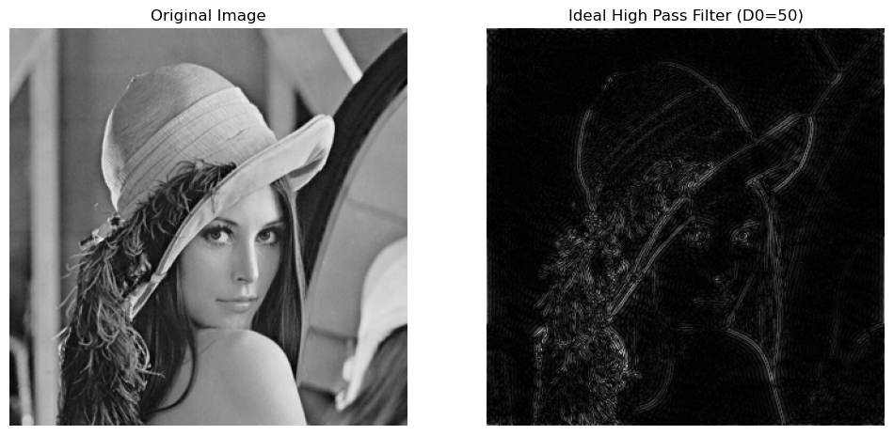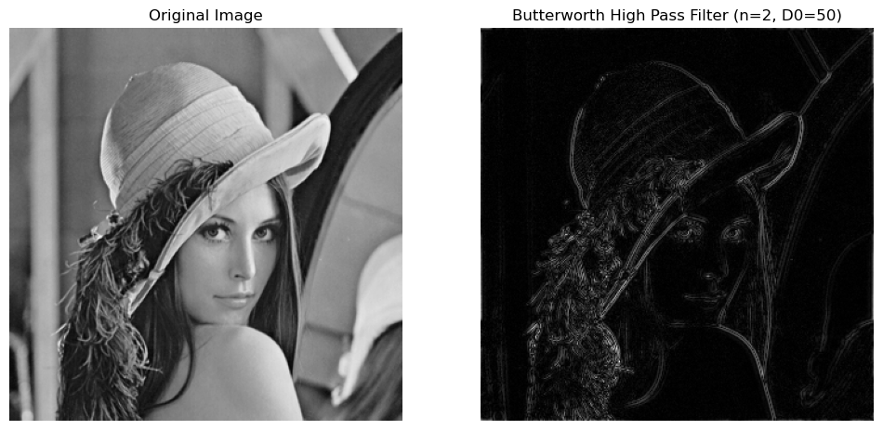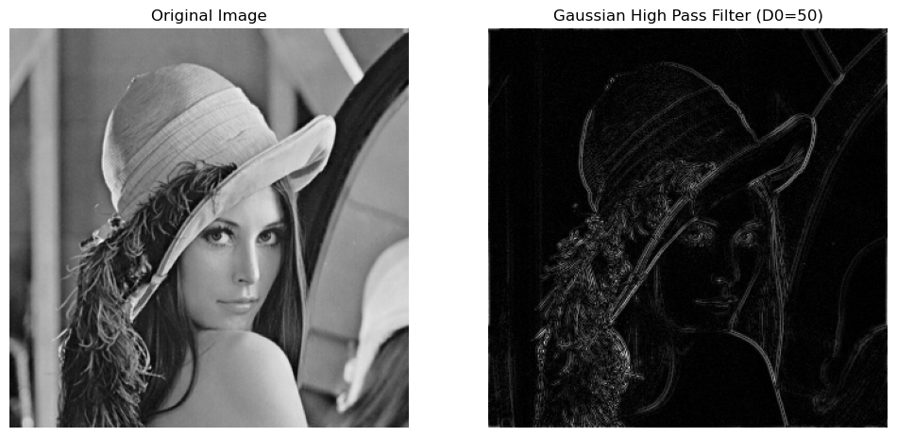
# Apply Ideal High-Pass Filter with ringing effect demonstration
cutoff = 30 # Sharp cut-off frequency to highlight ringing
H_ideal_ringing = ideal_high_pass_filter(img.shape, cutoff)
ideal_filtered_img_ringing = apply_filter_and_inverse(f_transform_shifted, H_ideal_ringing)
plot_images(img, ideal_filtered_img_ringing, f"Ideal High Pass Filter - Ringing Effect (D0={cutoff})")

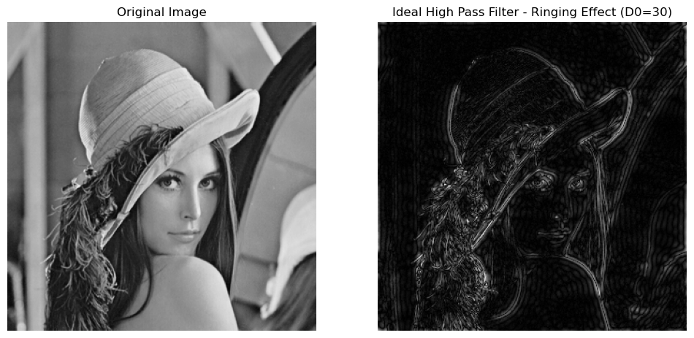
# Compare Butterworth High-Pass Filters for different cutoff frequencies
cutoffs = [5, 15, 30, 90, 120]
n = 2 # Fixed order of the filter

for c in cutoffs:
H_butterworth = butterworth_high_pass_filter(img.shape, c, n)
butterworth_filtered_img = apply_filter_and_inverse(f_transform_shifted, H_butterworth)
plot_images(img, butterworth_filtered_img, f"Butterworth High Pass Filter (n={n}, D0={c})")

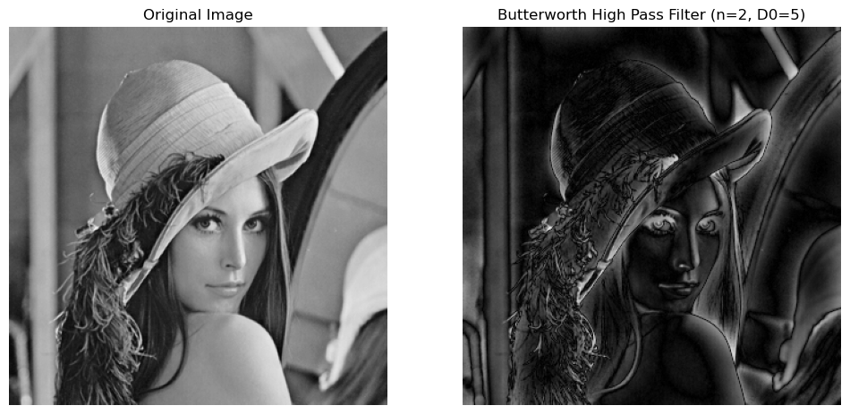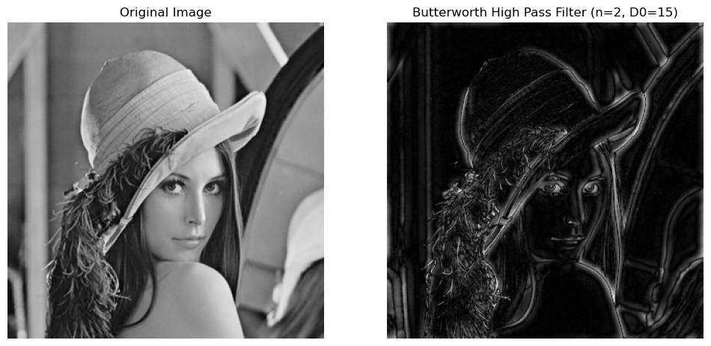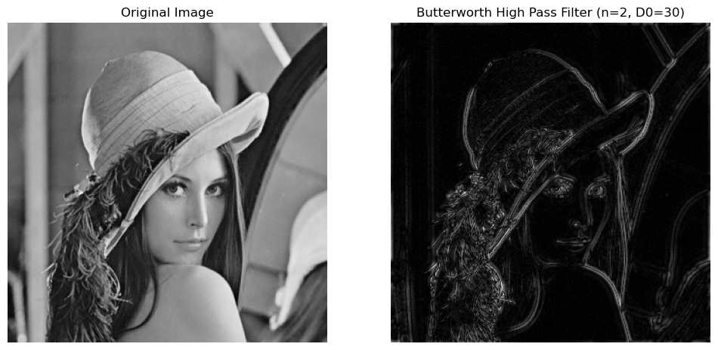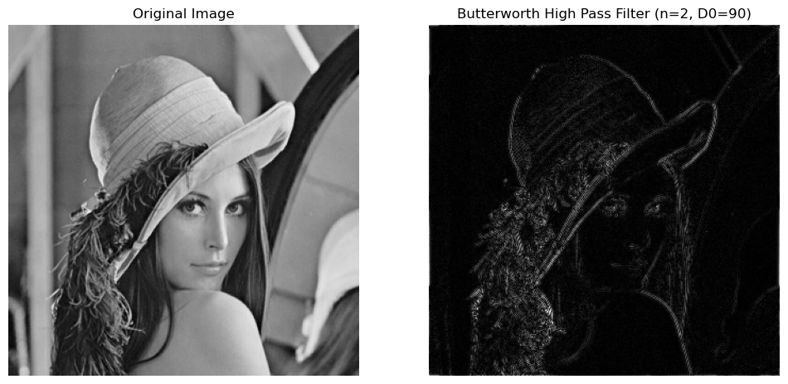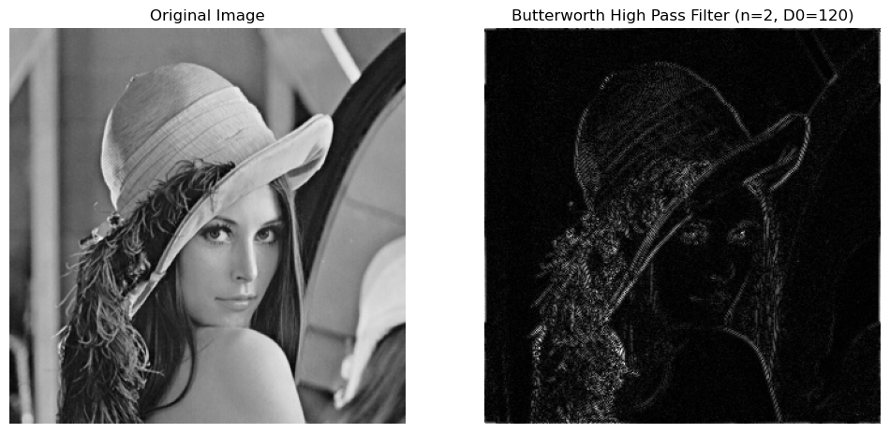
# Compare Gaussian High-Pass Filters for different cutoff frequencies
cutoffs = [5, 15, 30, 90, 120]

for c in cutoffs:
H_gaussian = gaussian_high_pass_filter(img.shape, c)
gaussian_filtered_img = apply_filter_and_inverse(f_transform_shifted, H_gaussian)
plot_images(img, gaussian_filtered_img, f"Gaussian High Pass Filter (D0={c})")

